**VMware Datastore Monitoring**

The VMware Datastore Alert allows users to monitor resource utilization and notify when the specified threshold has been breached. By default, this monitoring rule is create when then [VMware Hypervisor API](https://support.goliathtechnologies.com/hc/en-us/articles/360024629034) has been configured, along with the subsequent storage and VM rules.

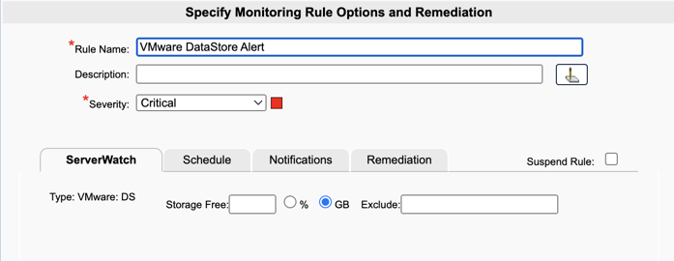

**Create a New Monitoring Rule**

1. To create a new monitoring condition, navigate to the **Configure - Monitoring Rules** page and click the **New** button
2. A selection pane will appear, click the **+** button next to **VMware ESX/ESXi Watch** to expand the options
3. Click the radio button next to **VMware ESX/ESXi Watch - Datastore Watch** and then click **OK**
4. Now the monitoring rule pane will appear. At the top of the pane name the Monitoring Rule via the **Rule Name** field, as well as define the description and the severity.
5. The first tab, **ServerWatch** is where you will define condition(s) to be monitored.
   1. **In the Storage Free** field, specify the threshold for the storage space in units of either Percent (%) or Gigabytes (GB), chosen via the radio buttons next to the field in which you'd like to monitor. An alert will be triggered if the the free space drops below this threshold.
6. In the **Selections** tree, select the datastore(s) that you want to monitor the specified condition on
   1. Please note, a machine can only be applied to one VMware ESX/ESXi Datastore monitoring rule type at a time. If there is no checkbox option, hover over the bell icon to get the name of the monitoring rule that the machine is currently applied to.

**Configure the Schedule**

The **Schedule** tab of a monitoring rule allows users to define how frequently the rule will alert. This can be done by adjusting the following fields:

* **Alert Every Time**: Defines whether an alert is generated every time the conditions are on the previous tab are met.
  + When checked the alert is generated every time the conditions are met.
  + When unchecked, the alert is only generated if the alert conditions are met, and the Minimal Notification Interval is exceeded since the last alert for this type.
* **Minimal Notification Interval**: Defines the minimal interval that must elapse between events for this alert before another alert will be generated.
  + The Alert Every Time checkbox must be unchecked in order to use this option.
  + For ServerWatch IP Services, this also defines the minimum elapsed time since a service is first detected as down or failed before an alert is generated.
* **Maximum Notification Interval**: Defines the maximum number of times you want to be notified during a continuous failure situation.
  + A value of 0 means no maximum is defined so you will continue to be notified according to your Alert Every Time and Minimal Notification Interval settings.
  + A non-zero value means that after you have been notified the number of times defined in the Maximum Alert Notifications, and according to your Alert Every Time and Minimal Notification Interval settings, you will not be notified again.
* **Notify On Restore**: Defines whether a 'Restore' alert is generated if you have previously been alerted due to a failure.
  + There is always a Notify on Restore for a ServerWatch for IP Service
* **Service Check Frequency, Every**: Defines the frequency with which the service specified for this Monitoring Rule is checked. It is no recommended to do this check any fewer then 3 mins.
* **Alert 1st Time After X Failures:**Define a value 1 or greater that defines how many successive failures should occur before the 1st alert notification 'Action' is executed.
  + The **Alert Every Time** and **Minimum Notification Interval** settings do no become applicable until after this threshold setting is exceeded.
  + The default value for this setting is blank which means not applicable. When not applicable, the **Alert Every Time** and **Minimum Notification Interval** settings are active immediately and the 1st alert does not occur until the **Minimum Notification Interval** threshold is equaled or exceeded if it is active.

**Additional Configuration**

For additional configuration options please see the following articles:

* Enabling Notifications:
  + [Configure Email and Text Alert Notifications](https://support.goliathtechnologies.com/hc/en-us/articles/360024446933)
  + [Configure SNMP Alert Notifications](https://support.goliathtechnologies.com/hc/en-us/articles/360024726913)
  + [Configure Syslog Alert Notifications](https://support.goliathtechnologies.com/hc/en-us/articles/360024346594)
* [Configure Custom Remediation](https://support.goliathtechnologies.com/hc/en-us/articles/360024446633)